**Name:** <Dessa Shapiro> **Date:** < 1/28/21> **Period**: <period 3>

1. What is Kepler’s First Law? Describe it with words. Create a drawing with labels that explains it

<kepler's first law is that orbits are ellipse with 2 foci points they center around >

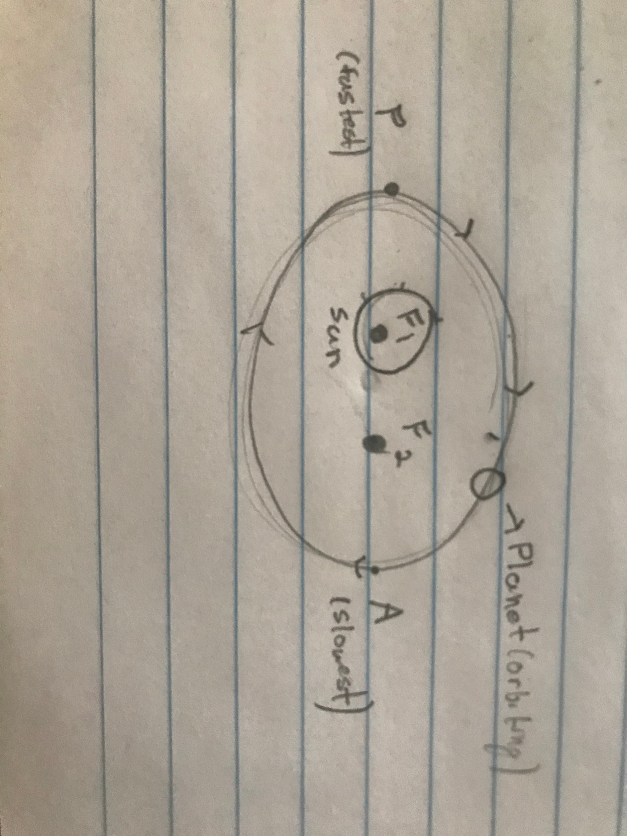Post a picture of your diagram here>

1. What is the equation for finding the eccentricity of an ellipse? If the distance between the foci is 0.5 and the major axis is 12, what is the eccentricity? Show your work below.

The equation would be Eccentricity = 0.5/12, Ec = around 0.042

1. Describe the movement of orbiting bodies. Think about the gravity well simulator when you create your description.

<orbiting bodies move in move around a foci in curved cycles called orbits, these orbits are formed whenever an object is in motion in a forward direction and being pulled by a center of gravity for another object(such as a sun) in a plan-like shape >

1. If you can’t find the other focal point (The sun is at one, but the other is empty) but you can find the perihelion and aphelion, you can calculate the eccentricity.

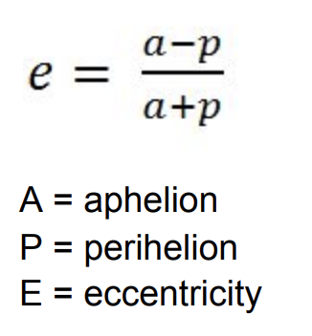

Calculate the eccentricity of the orbits of our 8 planets and most notable comet.

| Name | Aphelion (AU) | Perihelion (AU) | Eccentricity |
| --- | --- | --- | --- |
| Mercury | .47 | .32 | <0.1899> |
| Venus | .73 | .72 | <0.0069> |
| Earth | 1.02 | .98 | <0.02> |
| Mars | 1.67 | 1.38 | <0.0951> |
| Jupiter | 5.46 | 4.95 | <0.04899> |
| Saturn | 10.12 | 9.05 | <0.05582> |
| Uranus | 20.08 | 18.38 | <0.04420> |
| Neptune | 30.44 | 29.77 | <0.01113> |
| Hailley’s Comet | 35.1 | .59 | <0.96694> |



6. Which planet has the most circular orbit?

<The planet Venus has the most circular orbit because its eccentricity is the closest to 0.

7, Which planet has the most eccentric orbit?

<The PLANET mercury has the most eccentric orbit because it had the greatest number and other then that it would be halley's comet.>

8. How do the orbits of planets compare to the orbit of the comet?

<The orbits of the plants are much less eccentric then the orbit of the comet. The comet has a very large aphelion and a very small perihelion, while to planets have much closer numbers >